37 The Endocrine System
1.communication:Direct,Synaptic ;Paracrine ;Endocrine
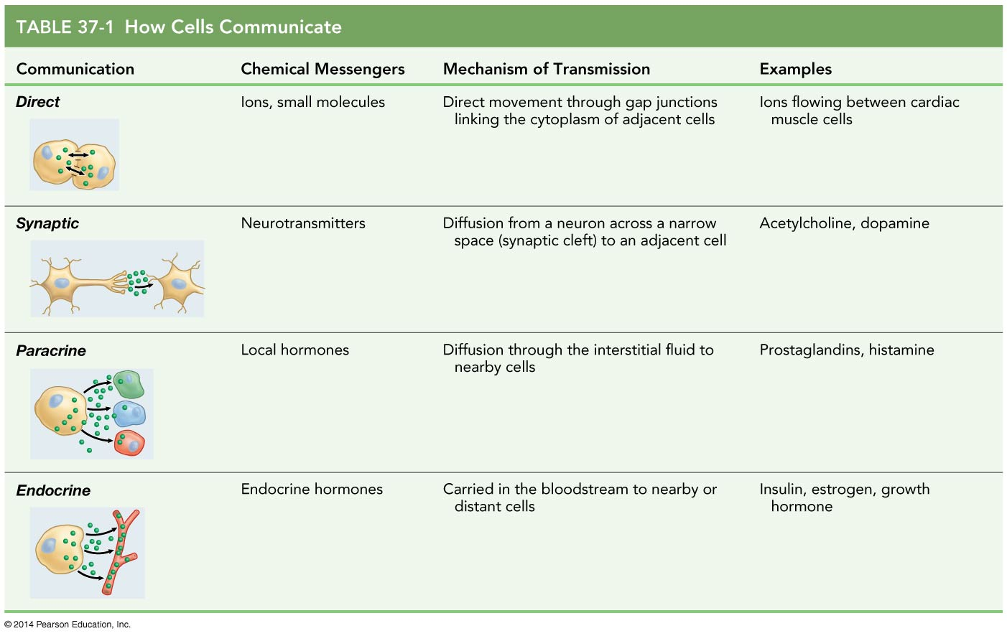
（1）receptors：each capable to binding a specific messenger and stimulating a particular response
（2）hormone定义:a chemical that is secreted into the interstitial fluid and carried by the interstitial fluid or bloodstream to other cells, where it causes specific effects in target cells.
(Local hormones;Endocrine hormones)
（3）Neurotransmitter;Synaptic communication定义
（4）Paracrine communication acts locally：如allergic and inflammatory responses,
（5）Endocrine communication（circulatory system）carry hormones to target cells throughout the body；如hormone oxytocin

2.three classes of vertebrate endocrine hormones：Peptide hormones；Amino acid-derived hormones,；Steroid hormones（lipid soluble）
（1）Hormone–receptor binding的2个影响：activating or inhibiting enzymes；Affecting gene transcription；
（2）second messenger：如cyclic adenosine monophosphate (cyclic AMP)
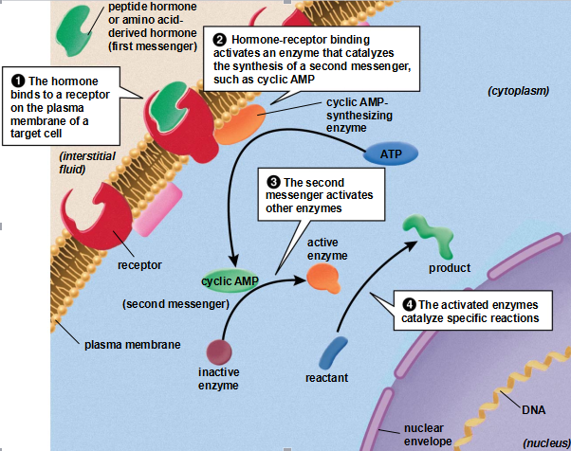
（3）Steroid hormones ：usually bind to receptors inside target cells
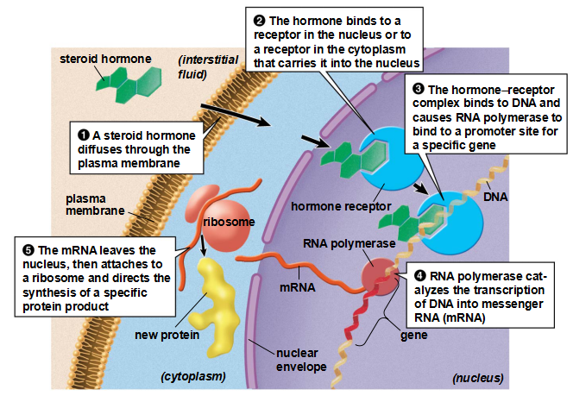
- 负反馈调节Hormone release：Negative feedback is a response to a change that tends to counteract a change and restore the system to its original condition ，如ADH.少量positive feedback：enhances the change

3.mammalian endocrine system：endocrine hormones and the glands 以下是具体的例子，每个器官分泌的激素及相应的作用均要了解
【Hormones of the hypothalamus and pituitary】 ：a.anterior pituitary produces and releases multiple hormones； b.Hypothalamic hormones control the release of hormones in the anterior pituitary; c. posterior pituitary releases hormones synthesized by cells in the hypothalamus
【thyroid and parathyroid glands】： influence metabolism and calcium levels ；Thyroxine influences energy metabolism ；Thyroxine release is controlled by the hypothalamus and anterior pituitary ，goiter的原因： An iodine-deficient diet can reduce the production of thyroxine and trigger a feedback that attempts to restore normal hormone levels by increasing the number of thyroxine-producing cells. Parathyroid hormone and calcitonin regulate calcium metabolism
【pancreas】 ：has both digestive and endocrine functions
insulin and glucagon ：control glucose levels in the blood ；
diabetes mellitus：Lack of insulin production or the failure of target cells to respond to insulin results in diabetes mellitus
two forms of diabetes其特点及机理；
【sex organs】： produce both gametes and sex hormones
【The adrenal glands】 secrete hormones that regulate metabolism and responses to stress；
- adrenal cortex produces steroid hormones ：Glucocorticoids help control glucose metabolism ，Mineralocorticoids regulate salt metabolism
- The adrenal medulla produces amino acid-derived hormones
- Hormones are also produced by the pineal gland, thymus, kidneys, digestive tract, heart, and fat cells （一些典型的激素及其功能）

