**38 The nervous system**

1. **Neurons**, often called nerve cells, which receive, process, and transmit information; **Glia,** which assist neuronal function by nutrients,Regulating extracellular fluid,Modulating communication ,Speeding up
2. **Neuron构成:**

Dendrites树突（respond to stimuli——Dendrites of sensory neurons 感觉神经元；Dendrites of neurons in the brain and spinal cord：neurotransmitters 神经递质）

cell body(incoming signals are positive enough—action potential 动作电位)

axon轴突（conducts action potentials）——Synaptic terminal突触末端（ transmitted to another cell—synapse包括3部分：synaptic terminal；dendrite or cell body；small gap ）

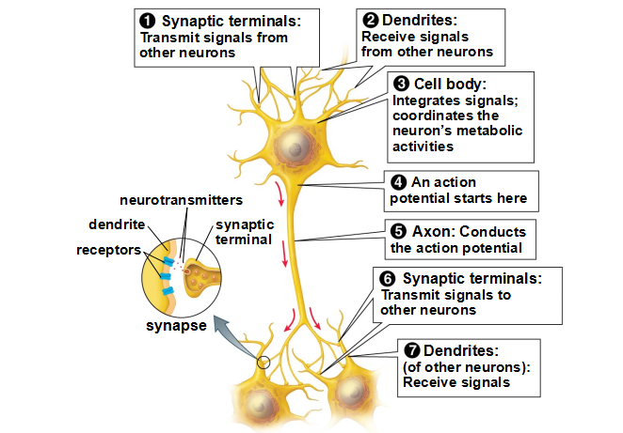【重要】

Function：Receive information；produce electrical signals；Conduct 传导 electrical signals ；Transmit information to other neurons

1. information的传递：within a neuron—electrical signals；between neurons—neurotransmitters
2. **在neuron中的传递**：unstimulated—resting potential 静息电位（内负）— less negative—threshold 阈值—action potential（内正）—恢复

Myelin 髓鞘（formed by glial cells）——speeds up（axon越厚传递越快）

1. Neurons之间传递：

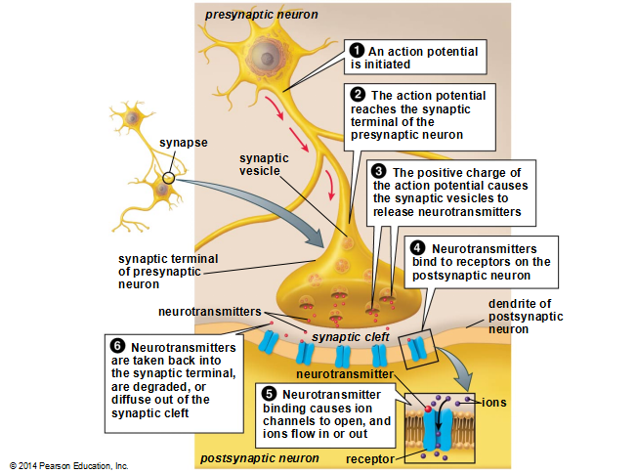

binding of neurotransmitter molecules to receptors——opens ion channels 离子通道 in the neuron’s plasma membrane——postsynaptic potential or PSP

1. inhibitory postsynaptic potential (IPSP) 抑制性突触后电位
2. excitatory postsynaptic potential (EPSP) 兴奋性突触后电位

integration 整合——Integration of postsynaptic potentials determines the activity of a neuron

1. behavior的控制：Sensory neurons 感觉神经元（specialized to respond to specific stimuli）—Interneurons 中间神经元—Motor neurons 运动神经元—Effectors 效应器

Code intensity：requency of action potentials in a single neuron；quantity of neurons

Behaviors are controlled by networks of neurons in the nervous system，如reflexes 反射作用

1. simple animals 如Cnidarian ：nerve net 神经网络 & ganglion 神经节，但无real brain
2. other animals： bilaterally 双向地symmetrical, with definite head and tail ends （如头部集中sense organs）
3. **Mammalian nervous system：**
4. **The central nervous system (CNS) 中枢神经系统**, consisting of the brain and spinal cord

功能：receives and processes sensory information, generates thoughts 思想, and directs responses ；

保护机制：bony armor（颅骨等）；Three layers of connective tissues；Cerebrospinal fluid 脑脊液；blood–brain barrier 血脑屏障；

（1）The spinal cord controls many reflexes and conducts information to and from the brain；

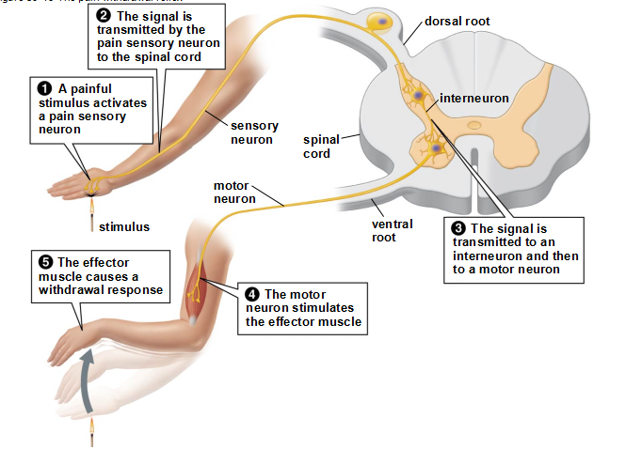

（2）The brain consists of ——The hindbrain 后脑（medulla , pons 脑桥, and cerebellum 小脑）（breathing and heart rate ）

The midbrain 中脑 （vision，movement, arousal 兴奋, and emotion ）

The forebrain 前脑（thalamus丘脑 , hypothalamus下丘脑 and cerebrum大脑 ）（sense of smell ）

左右脑功能不同： left hemisphere is usually dominant in speech, reading, writing, language comprehension, mathematical ability；The right hemisphere is superior to the left in musical skills, artistic ability, recognizing faces, spatial visualization, and the ability to recognize and express emotions

学习：short-term memory（the repeated activity of a particular neural circuit 神经回路 in the brain, and as long as the circuit is active, the memory stays ） and long-term memory （persistent changes in the expression of certain genes ）

看一下PPT上与这些各部分相联系的功能

B. **The peripheral nervous system (PNS) 外周神经系统**, consisting of neurons and axons that lie outside the CNS（3种axon）

somatic nervous system 躯体神经系统control voluntary movement；

autonomic nervous system 自主神经系统 controls involuntary actions（The sympathetic division 交感神经部分—neurotransmitter norepinephrine 去甲肾上腺素；The parasympathetic division 副交感神经部分—acetylcholine 乙酰胆碱）；