Chapter 39 The Senses
- The process to produce sensory perception(知觉)
Sensory receptors→axons(or synapses→neurons→axons)
→CNS(brain or spinal cord)
- sensory receptor
*definition: specialized cell that produces an electrical signal in response to specific stimuli
*contain certain receptor molecule.
*receptor potential: bring the neuron above threshold and trigger action potentials.
**vary in size: small: produce one or two action potentials
large: produce a high frequency of action potentials
- Mechanoreceptors
- Position: skin(touch, vibration, pressure), internal organs(stretch), inner year(sound, gravity, movement)
- Charactiristics:
* the endings of several types of mechanoreceptor neurons are embedded in the human skin which produce receptor potentials when their membranes are stretched or dimpled（包裹在皮肤里）
**free endings
**enclosed in accessory structures
*The density of mechanoreceptors in the skin varies tremendously over the surface of the body（密度的差异）
*Mechanoreceptors in many hollow organs,
joints and muscle are signaled by responding to stretch
*important to animals
3.sound detection
(1)two functions of ears
(2)structures of ears(Three parts)
*The outer ear: pinna and the auditory canal
*The middle ear: the tympanic membrane (eardrum)[鼓膜]; three tiny bones [ hammer 锤骨(malleus), anvil 砧骨(incus) , and stirrup 镫骨(stapes)]; the auditory tube 耳咽管(Eustacian tube)
(3)sound waves are converted into electrical signals这个过程要清楚
Pinna(collection)→auditory cannal→eardrum→Three small bonds→oval window→fluid in the cochlea(round window move in opposite directions with oval window)→movement of the basilar membrane→hair bend of hair cells→auditory nerve
图是PPT上的原图，可根据图示理解声波被耳转化成电信号的过程

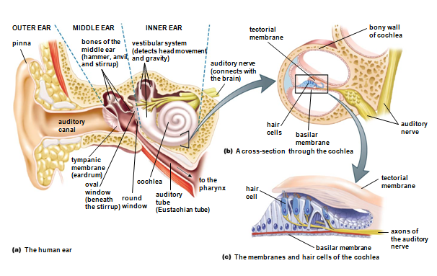

- loudness and pitch generation
*loudness: small receptor potential
Large receptor potential
*pitch: high notes: oval window →high pitch
Low notes: near the tip of the cochlea →low pitch
- detection of gravity and movement
- collected by vestibular apparatus in the inner ear:
vestibule and the semicircular canals
- vesitubule: utricle and saccule
- three semicircular canals are perpendicular to each other
- detection of light
- photoreceptors
- compound eyes
- how mammalian eyes function
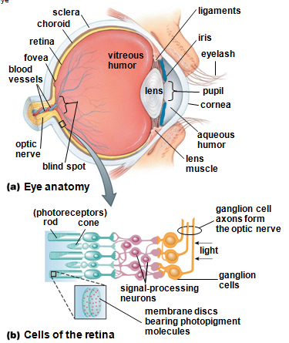

光通过眼睛的过程要了解
*nearsighted and farsighted
*retina(contains photoreceptors)
**Cones (视椎神经)三种，不同的pigment→color
在fovea富集 在白天活动的生物只有cones
**rods(视杆神经)比cones更大，相同的色素
在夜间活动的生物主要或全部是rods
*binocular vison

