**Chapter 40 The Muscles and Skeleton**

1. three types of vertebrate muscle
2. skeletal muscle

**\*结构：**

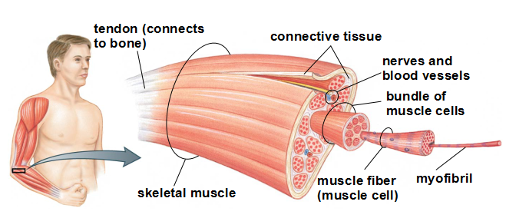

**下面这张图要能看懂，很重要，具体的内容对照课件9-14页** 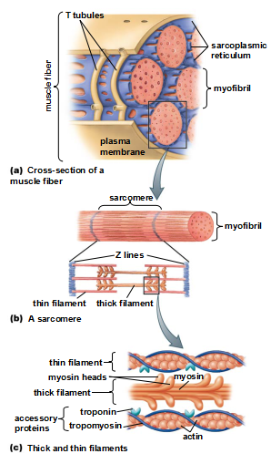

**\*收缩——sliding filament mechanism滑丝机制**

**下面这张图也很重要，要在理解的基础上记忆，内容见课件17-21**

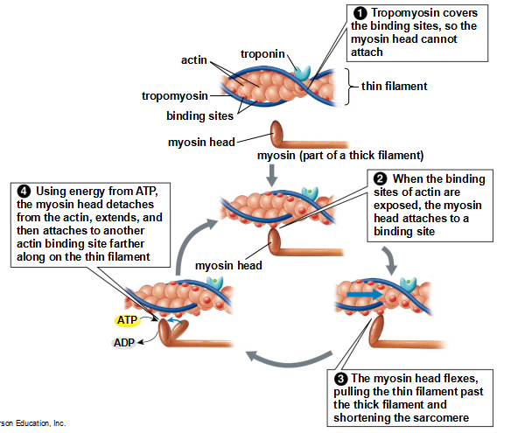

在收缩过程中，利用ATP和磷酸肌酸creatine phosphate供能

**\*under voluntary, or conscious, control**

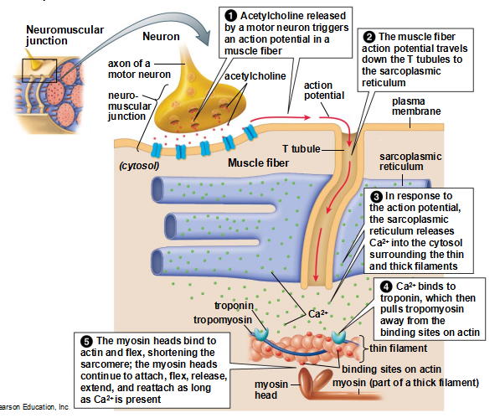

神经系统的控制：通过一种特殊的突触——神经肌肉接头

Controlling the force, distance, and duration of muscle contraction requires controlling how many fibers in a muscle contract and how long they contract.

*A motor neuron and all the muscle fibers that it stimulates are called a motor unit 运动单位 名词解释

*分类：slow- twitch and fast-twitch 快肌纤维(fast-twitch fiber)和慢肌纤维(slow-twitch fibers) 特点和区别

1. Cardiac muscle

形态，Cardiac muscle fibers are connected to one another by intercalated discs闰盘，收缩的特点

1. Smooth muscle

分布，形态，Smooth muscle fibers are directly connected to one another by gap junctions, allowing the cells to contract in synchrony，收缩的特点，Smooth muscle contraction is involuntary and can be stimulated by stretch, hormones, signals from the autonomic nervous system, or by combinations of these stimuli

1. Skeleton

Coordinated movement of an animal’s body is produced by alternating contractions of muscles with opposing actions, called antagonistic muscles拮抗肌—pairs of muscles with opposing actions that squeeze or pull on its skeleton

以下为在进化上出现的三种骨骼，了解它们的特点，如每种骨骼的拮抗肌分别是什么

（1）hydrostatic skeleton——Worms, cnidarians, and many mollusks

（2）exoskeletons——arthropods (such as spiders, crustaceans甲壳动物, and insects)

（3）Endoskeletons——echinoderms  棘皮动物and chordates脊索动物(vertebrates and their relatives)

功能：The skeleton provides a rigid framework that supports the body and protects its internal organs；The skeleton allows locomotion；In mammals, the bones of the middle ear are essential to hearing；Red bone marrow produces red blood cells, white blood cells, and platelets；Bones store calcium and phosphorus, absorbing and releasing these minerals as needed

The vertebrate skeleton consists of two parts：

The axial skeleton中轴骨，The appendicular skeleton  附肢骨骼

The vertebrate skeleton is composed of： cartilage, ligaments, and bone.了解它们各自的组成

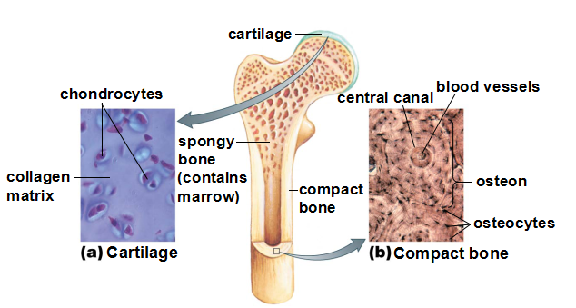

骨细胞有三种：Osteoblasts成骨细胞，Osteocytes骨细胞，Osteoclasts破骨细胞 它们的特点，功能，**骨折以后的重塑**

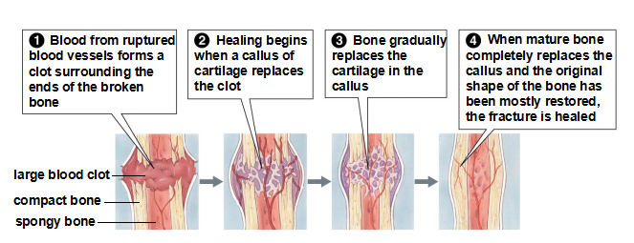

Antagonistic muscles move joints

Immobile：sutures

Movable：Joints are held together by **ligaments** that are strong and flexible but usually not very elastic .**Tendons** attach muscles to the bones

Hinge joints铰链关节

ball-and-socket joints球窝关节