33 Respiration
- respiration定义:Organismal respiration, which we will simply call respiration, is the process by which organisms exchange gases with the environment, taking in oxygen and releasing CO2, in support of cellular respiration.
- 生物体内气体交换——diffusion：要求具有浓度梯度（bulk flow）；
- 促进diffusion的3个adaptations:（moist，thin，large surface）
- inactive animals无特化的呼吸器官，如Sponges，Sea jellies等，这些动物generate additional bulk flow来获得充足气体交换的方式
- 呼吸系统和循环系统通常协同配合
- Gas exchange的4个步骤：Bulk flow carries air or water——O2 diffuses through the respiratory surface and into the capillaries，CO2 diffuses out of the capillaries ——Bulk flow of blood transports gases in body——Diffusion transfers O2 out of the capillaries and into nearby tissues, transfers CO2 from the tissues into capillaries. 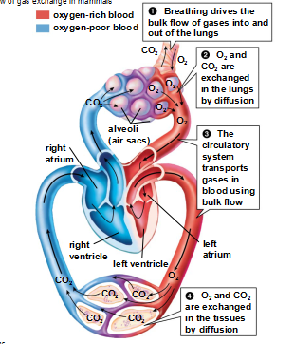
- Gills鳃：许多水生生物的呼吸结构；鳃的形态branched or folded to increase their surface area；
- countercurrent exchange定义
- Insects的呼吸结构: tracheae气管,spiracles通气孔,tracheoles微气管
vertebrates的呼吸结构：lung
- 陆生动物需要可以起保护支持且防止水分流失的internal respiratory structures；
鸟的lung：air sacs（inflate充气-deflate放气）；parabronchi副支气管；
- 【掌握】哺乳动物的呼吸系统可分为两部分——1.conducting portion【carries air to the lungs了解这个过程：Inhaled air—larynx—trachea气管—bronchi支气管—bronchioles细支气管—alveoli肺泡（gas exchange occurs；surfactant表面活性剂的作用prevents the fragile alveolar surfaces from sticking together；respiratory membrane包括：epithelial cells of the alveoli & endothelial cells that form the wall of the capillary across which gas exchange occurs ）；makes speaking possible】；2.gas-exchange portion
12.【chest cavity与diaphragm在呼气与吸气时的收缩情况】Air is inhaled actively and exhaled passively（bulk flow）——Inhalation（chest cavity is enlarged &diaphragm横膈downward）；Exhalation （occurs spontaneously when the muscles that cause inhalation are relaxed：chest cavity shrink&diaphragm upward）
13.pharynx咽部——epiglottis会厌——larynx 喉部（voice box：contains vocal cords声带）；注意这3个结构的功能和位置；The opening to the larynx is guarded by the epiglottis会厌, a flap of tissue supported by cartilage；Heimlich maneuver海姆立克急救法
14.大脑呼吸中枢控制呼吸速率（located in the medulla 延髓）；diaphragm and rib muscles are not self-activating；
15.氧气&二氧化碳在血液中的不同运输机制：
氧气的运输： diffusion gradients favor；hemoglobin
二氧化碳的运输：diffuses into nearby capillaries—bloodstream——respiratory membranes of the alveoli；三种运输方式：dissolved ； hemoglobin；CO2 +H2O ——H+HCO3，HCO3 diffuses into the plasma，alveoli：H+HCO3——CO2 +H2O，CO2 exhaled；

