Chapter 35 The Urinary System
- Urinary systems（泌尿系统）定义、功能（produce and eliminate urine）；Excretion（排泄）定义、功能（wastes are eliminated from the body）
- Urine（尿：nitrogen-containing compounds—break down of the amino acids{Ammonia、Urea、Uric acid}）
freshwater organisms—ammonia ； Terrestrial animals—less toxic urea or uric acid，如liver converts ammonia to urea，In kidney nephrons, urea is filtered into the urine
- 无脊椎动物的Urinary system：
对simple animals只是为了water balance或regulate the composition of the body fluids；
如A.Sponges and cnidarians—diffusion and active transport；
B.flatworms—Protonephridia（原肾管）filter interstitial fluid 其机制：Flame cells produce a current that draws interstitial fluid into the tubules through the slit-like openings;
C.insects—Malpighian tubules（马氏管） filter the hemolymph of insects（end blindly）
D.annelid环节动物worms and mollusks软体动物—nephridia（肾管）filter interstitial fluid
- 【Mammalian Urinary System结构】：Kidneys、Ureters、Bladder、Urethra
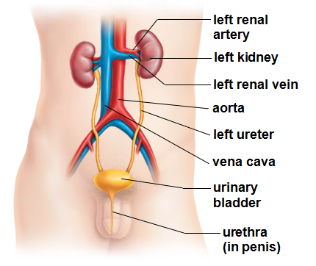
过程：blood flow through the kidneys；renal artery进renal vein出（filter）——Nephrons肾单位in the kidneys filter blood and produce urine——glomerulus肾小球（glomerulus & little tube，Bowman’s capsule肾小球囊 ; 鲍氏囊）——peritubular capillaries,肾小管管周毛细血管网——renal vein
【Nephrons】：Bowman’s capsule——proximal tubule近曲小管——he loop of Henle亨利氏环—— distal tubule远曲小管（iltrate is converted into urine）——collecting duct集合管（not part of the nephron）
- Urine Formation：【在nephrons 中产生的3个步骤】：
Filtration（water and most small dissolved molecules are filtered out）—— Tubular reabsorption（ water and necessary nutrients are restored to the blood）—— Tubular secretion（wastes and excess ions that still remain in the blood are secreted into the urine：primarily by active transport, takes place in both the proximal and distal tubules）
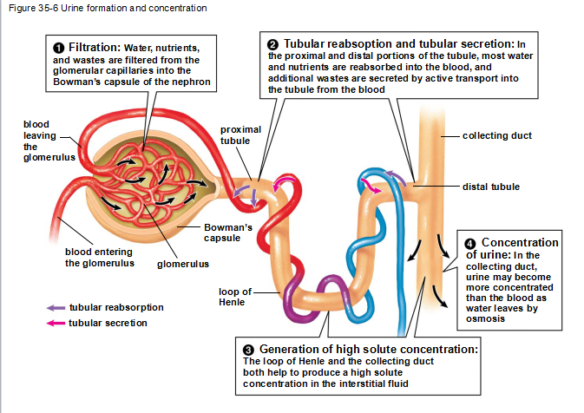
- Urinary Systems Help Maintain Homeostasis：
【Vertebrate urinary systems（4点）】——Retaining small organic nutrients；Regulating the water and ion content ；Maintaining the proper pH ；Secreting substances that help regulate blood pressure and blood oxygen content；
Kidney：Reabsorption of water— passively by osmosis ；
【ADH抗利尿激素（antidiuretic hormone）】：regulate Water permeability of the distal tubule and collecting duct （通过aquaporins水通道蛋白调节）；例如：失水——blood osmolarity 升高——hypothalamus stimulates the pituitary gland to release ADH——distal tubule and collecting duct insert more aquaporins into their membranes——increasing their permeability to water【negative feedback】
适应性：Mammals adapted to dry climates ——high percentage of nephrons with long loops of Henle——more water to be reclaimed；
maintain blood pH： kidneys secreting excess H+ into the tubule for excretion and by reabsorbing HCO3- into the blood（proximal and distal tubules of the nephrons）；
regulate blood pressure：pressure falls——kidneys release the enzyme renin肾素——form hormone angiotensin血管紧张素（通过3种方式对抗低血压：aldosterone醛固酮；ADH；arterioles constrict）；
reduced oxygen——kidneys release erythropoietin促红细胞生成素；
- osmoregulation 渗透压调节
Fish nephrons——lack loops of Henle——cannot produce concentrated urine

