Chapter 23 Animal diversity I :Invertebrate

1. 需要掌握的知识点和可能考的大题

1.**What Are the Key Features of Animals?（去年期末考了这道大题）**

Animals possess all of the following characteristics:

– Eukaryotes

– Multicellularity

– Their cells lack a cell wall

– They obtain energy by consuming other organisms

– Most reproduce sexually

– They are motile at some point in the life cycle

– They are able to respond rapidly to external stimuli

2.several important features in animal evolutionary:

1)The appearance of tissue

2)The appearance of body symmetry

3)Protostome and deuterostome (原口动物，后口动物）

1. ）The only animal that lakes tissue is Sponges.(海绵)

Tissue（名词解释）

1. ）Symmetrical animals radial symmetry (辐射对称)

两大类 Bilateral symmetry(两侧对称)

①辐射对称动物的特点：

Have multiple symmetry planes;Have two embryonic tissue layers:Ectoderm and Endoderm(每个胚层发育成什么要清楚)；

②两侧对称动物的特点：

a.Exhibit cephalization；b.Have three embryonic tissue layers,plus the mesoderm(中胚层发育成什么要清楚)；

c.Most have body cavities(a variety of functions)

Coelomates(真体腔动物)——coelom

Pseudocoelomates(假体腔动物)——pseudocoelom

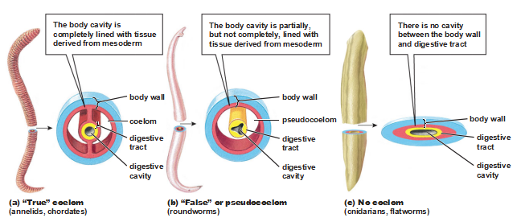 Acoelomates(无体腔动物)

3.)Bilateral organisms develop in one of two ways based on embryological development

①Protostome( 原口动物) development

在胚胎发育中由原肠胚的胚孔形成口的动物.原口动物的胚胎发育为螺旋定型卵裂，中胚层形成是在原口两侧的内、外胚层交界处各有一个细胞分裂为很多细胞，形成索状伸入内、外胚层之间，形成中胚层；原口动物这种形成中胚层的方法称为端细胞法（又称裂体腔法）

②Deuterostome( 后口动物) development

原肠胚期,其原口形成动物的肛门,而在与原口相对的一端,另形成一新口.后口动物的胚胎发育是辐射不定型卵裂；在原肠期的后期，与原口相反一端的内外两胚层相互贴紧，最后穿成一孔，成为幼虫的口，后口动物因此得名。这些动物的原肠背部两侧，内胚层向外突出成对的囊状突起体腔囊，体腔囊和内胚层脱离后，在内、外胚层之间逐步扩展成为中胚层。这种形成方法称为肠体腔法.

1. What Are the Major Animal Phyla?

这部分内容以了解为主，考查要求不高。自己要总结每个动物门的特点，尤其是有无头和脑，有无循环系统和呼吸系统，循环系统为开放式或封闭式，体腔为真或假体腔等特点（课后填空题有利于总结）。关于动物门类名称的专业词汇，应当要眼熟，看到能知道意思。

There are **27** animal phyla in present,most are invertebrate and less than **3%** are vertebrate.

① Phylum Porifera 海绵动物门

不能运动，形态、大小多样；缺乏组织和器官；可以通过budding无性生殖，也可以是精卵结合的有性生殖;有四种类型细胞Epithelial cell上皮细胞；pore cell孔细胞；amoeboid cell变形细胞；collar cell领细胞（每种类型细胞作用要清楚）

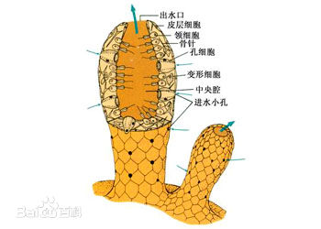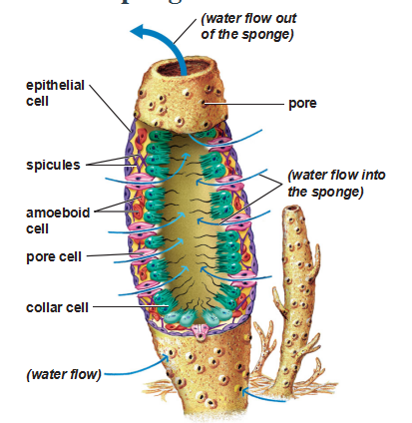

②phylum Cnidaria 腔肠动物门

都是carnivorous predators(肉食动物)；有两种明显的组织 contractile muscle-like tissue，an organized nerve net网状神经系统;无器官和脑；有两种类型polyp(水螅型) 和 medusa(水母型)；有种特殊类型的细胞cnidocytes( 刺细胞)，捕获食物和防御之用；有gastrovascular cavity 消化循环腔

③phylum Ctenophora 栉水母动物门

Most comb jellies are hermaphroditic(雌雄同体)

④phylum Platyhelminthes 扁形动物门

Many species are parasites，most are hermaphroditic

They possess a distinct head, along with sensory organs，如涡虫的眼点，有神经节和神经索；但没有消化和呼吸系统；开始出现两侧对称；对人体有害的寄生性扁形动物有Tapeworms(绦虫)，flukes（吸虫）

⑤phylum Annelida 环节动物门

同律分节，The segments contain identical copies of nerves, excretory structures (排泄器官), and muscles that allows for complex movement；The fluid-filled coelom functions as a hydrostatic skeleton(流体静力学性骨骼)；closed circulatory system；nephridia(肾管)为排泄器官；The annelid digestive system consists of a tubular gut with two openings—a mouth and an anus.分为以下三纲Oligochaetes(寡毛纲)--earthworms蚯蚓 、Polychaetes (多毛纲)、Leeches(蛭纲)

⑥phylum Mollusca 软体动物门

open circulatory systems,Blood percolates through a hemocoel(血腔) (or blood cavity), bathing the internal organs directly;有mantle(外套膜)；The three classes of mollusks are:Gastropods(腹足纲)，Bivalves(双壳纲)，Cephalopods (头足纲)

⑦phylum Arthropoda 节肢动物门

分为insects(昆虫), arachnids(蛛形类), myriopods(多

足类), and crustaceans(甲壳类)；有蛋白质和几丁质组成exoskeleton(外骨骼)。昆虫分为头、胸、腹三部分；用鳃、肺、气管呼吸；开管式循环系统；复眼；完全变态与不完全变态。蛛形纲的典型代表有 include spiders(蛛),mites(螨),

ticks(虱),scorpions(蝎);多足纲有centipedes(蜈蚣) and

millipedes(马陆);甲壳类有barnacles(藤壶).

⑧phylum nematomorpha 线形动物门

假体腔；有角质层；寄生性的有Hookworm(钩虫)和Trichinella(旋毛虫) .

⑨phylum Echinodermata 棘皮动物门

have a calcium carbonate skeleton； It consists of the sieve plate(筛板), a circular central canal, several radial canals, and numerous tube feet(管足).

⑩phylum Chordata 脊索动物门 two invertebrate groups:

-the sea squirts海鞘

-the lancelets文昌鱼

Vertebrates 脊椎动物

1. 可能考的名词解释

cephalization头部化 body cavities体腔 Protostome原口动物 Deuterostome后口动物 budding gastrovascular cavity metamorphosis