Chapter 34 Nutrition and Digestion
(一) Nutrient
1．Definition of nutrient
2. six major categories of nutrients【六种主要的营养物质】
(1)carbohydrate
— carbohydrates are a source of quick energy.
*glucose: from which cells derive most of the energy.
*cellulose, starch, glycogen 【在细胞中的作用要知道】
(2) lipids
—oils and fats are the most concentrated energy source
*great molecules to store energy(hydrophobic)
*overweight and obesity (BMI 18.5-24.9)
(3)proteins
*essential amino acid( adults : 9, infants婴儿:10, histidine)
(4)minerals(Ca, Mg, Na, K, P, Fe, I)【这几种元素的作用要知道】
(5)vitamins（量少但很重要）
*water soluble(Vitamin C,B Vitamin-complex )
*fat soluble (Vitamin A, D,E,K)
(6)water(The human body is about 60% water)
3．Supply energy: lipids, carbohydrate and protein(calories &Calories 大小写)
Essential nutrients: essential fatty acid, essential amino acid, a variety of minerals, vitamins and water

(二)Digestion and digestive system
1. digestion: the process that physically grind up food and then chemically breaks down it.
2. digestive system: consists of a series of compartment in which food is processed , as well as organs that produce secretions theat aid in digest
2. five tasks performed by digestive system: ingestion(采食), mechanical digestion(物理消化)，chemical digestion(化学消化), absorption(吸收), elimination(排泄)
3. types and examples
(1) intracellular digestion （胞内消化)【海绵进行胞内消化的过程要知道】
*sponges(滤食性动物)(microscopic particles)
*collar cells, food vesicle, phagocytosis, lysosome
(2)extracellular digestion
➔gastrovascular cavity(胃循环腔)
*single opening(ingestion and elimination)
* stinging tentacles (刺一样的触须)(capture prey) → Gland cells (secrete enzymes)→ nutritive cells(absorb the nutrients and Further intracellular digestion)
➔tubular digestive systems(很多动物，all vertebrates)
*one-way tubes: begins with a mouth and end with an anus
*examples: earthworm and vertebrate digestive systems
➔➔vertebrate digestive systems
(1)specialized according to their diets: Carnivores (食肉动物), Herbivores (食草动物)
Omnivores (杂食动物)
Difference in their teeth and length of small intestine.
(2)Major organs of vertebrate systems: mouth, esophagus, small intestine, large intestine (some vertebrates have specialized chambers)
(3)examples:
*birds(lack teeth) :crop→stomach chamber #1→gizzard→small intestine(absorption)→large intestine
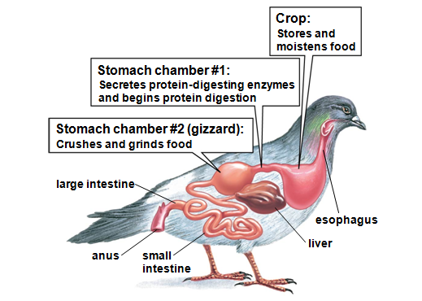
*ruminants(cow)
Multiple stmoch chamber
Rumen(microorganisms)→reticulum(cud) (regurgitated) Remen→omasum(absorption)→abomasum(protein)
(三)human digestive system
【这部分内容属于本章核心的内容，大家复习的时候一定要将ppt完整的看完，并且按照食物消化的顺序进行一定的梳理。这里我选取其中比较特殊的一些点进行罗列】
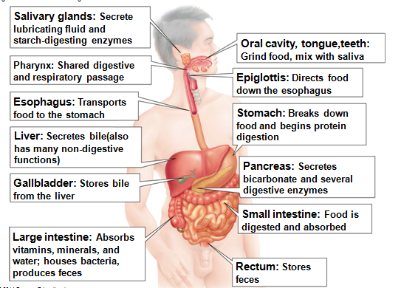
【这张图片的内容是整个人体消化系统的概况，比较重要，一定要弄懂】
1.salivary glands
- three pairs in human body
- contains amylase(淀粉酶)
2.epiglottis(function and how to work) ,esophagus(peristalsis,蠕动)
3.stomach
(1)sphincter muscle(the lower esophageal sphincter食道下端括约肌,the pyloric sphincter 幽门括约肌)(function)
(2)functions of stomach【尤其是三四点，要了解】
(3)gastric glands(include mucus, hydrochloric acid, and the protein pepsin胃蛋白酶)
4.small intestine【重要】
(1)three segments: duodenum(十二指肠)(regulate bile and pancreatic juice into the small intestine), jejunum(空肠) ,ileum(回肠)
(2)a variety of digestive substances
*bile(secreted by liver)
Functions of liver: convert toxic ammonia into urea
Gallbladder store bile
*Pancreatic juice (Pancreatic amylase, Lipase, Proteases)
*enzymes in the intestine wall.(peptidase)
(3)absorption
*villi and microvilli
*absorb: water, monosaccharides, amino acid and short peptides, fatty acid, vitamin, mineral
*fatty acid, cholesterol, fat-soluble vitamin:lactal(乳糜管，毛细淋巴管)
5.large intestine
6.control of digestion: nervous system(hypothalamus,下丘脑) and hormones

