Chapter 36 defenses against disease
- Three major forms of proteins against disease in vertebrate.【知道每一道防线包括什么】
- nonspecific external barriers
—skin
—mucous membranes of the digestive, respiratory, and urogenital（lysozome）
- nonspecific internal defenses(innate immune response)
—white blood cells（leukocytes）
*phagocytes(macrophages, neutrophils, dendritic cells )
【通过血液运输，透过毛细血管在组织中发挥作用】
*natural killer cells（NK，自然杀伤细胞）【杀死病毒侵染的细胞，杀死非我细胞】（MHC）
—the inflammatory response【受损细胞释放化学物质，刺激mast cell（肥大细胞）分泌histamine（组胺）】【结合ppt上的图理解过程】
—fever（pyrogens→hypothalamus）【引发一系列生化反应】
- specific internal defenses(adaptive immune response)
- Adaptive immune system
- component
*immune cells
Macrophages, dendritic cells, lymphocytes (B cells and T cells ,骨髓造血干细胞)
*tissues and organs
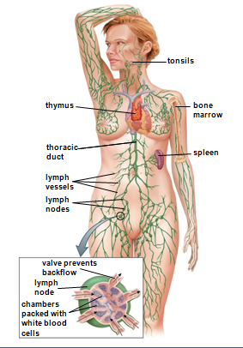
*secreted proteins(cytokines细胞因子, complement补体, antibody抗体)
**antibody（produced by B cells and their offspring）
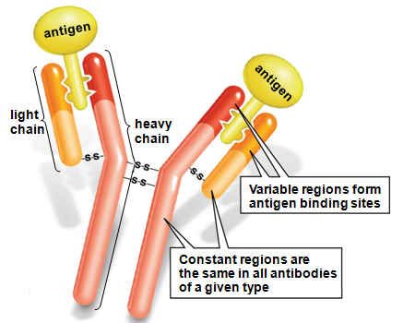

Types: lgD, lgM, lgG【最常见，最主要的抗原类型】 lgA, lgE
【了解每种类型抗原各自的分布与作用】
Two functions of antibodies.
**T-cell receptors（found only on the surface of T cells）(特异性强)

- three steps of adaptive immune response
*lymphocytes recognize an invading microbe and distinguish the invader from self.
**antigens
**antibodies and T-cell receptors recognize, bind and help to destroy foreign cells and molecules
**the immune system distinguishes self from non-self by retaining only those immune cells that do not respond to the body’s own molecules.
*launch an attack
*retain a memory of the invader that allows them to ward off future infections by the same type of microbes.
3.Humoral immunity and cell-mediated immunity
(1) humoral immunity 【清除位于细胞外的病原体】
*provided by B cells and the antibodies theay they secreted into the blood
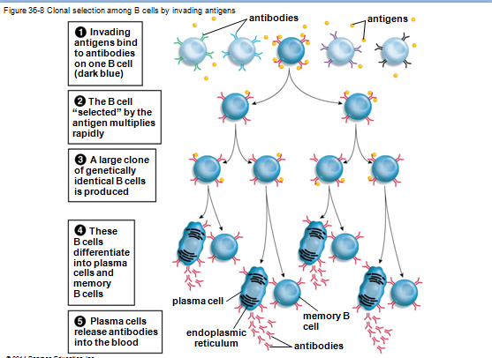
Clonal selections, memory B cell, plasma B cell
*three ways that antibodies function
**neutralization
**antibodies coat the surface of invading molecules, virus or cells.
**bind to microbes and interact with complements.
(2) Cell-mediated immunity 【清除位于细胞内的病原体】
*produced by cytotoxic T cells, which attack virus-infected body cells and cells that have become cancerous
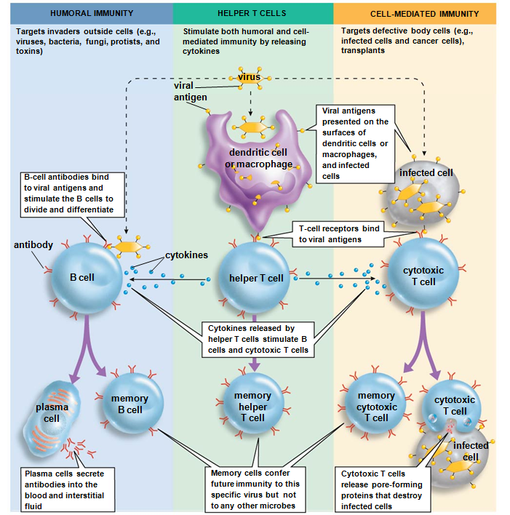
【这幅图很重要，一定要弄懂】
*memory B and T cells(helper T cell and cytotoxic cell)
4.antibiotics(resistance), antiviral drugs and vaccines
5.Immune system malfunction
(1) allergy (allergy antibody)
*allergens
* immune reactions to harmless substances that are treated as if they were pathogens
【结合ppt上的图进行理解】
(2)autoimmune disease (anti-self antibody)
(3)immune deficiency disease (hereditary immune deficiency and acquired immune deficiency)
SCID and AIDS(helper T cell)
6.cancer
*NK cells and cytotoxic T cell
*therapy: treatment of surgery, radiation and chemotherapy.

